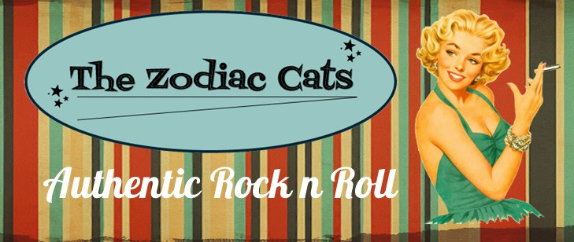

The Arkley Club, Barnet
L 17TH AUGUST 2024 L I ONSTAGE FROM 8:30 PM I
V ENTRANCE £5 V
E
E
Playing the best music from legends like Bill Haley, Elvis, Eddie Cochran and more

 instagram.com/zodiaccatsband


facebook.com/zodiaccatsband

